Trial Coordinator Stuff

Logon to trial manager on https://nstra.org/

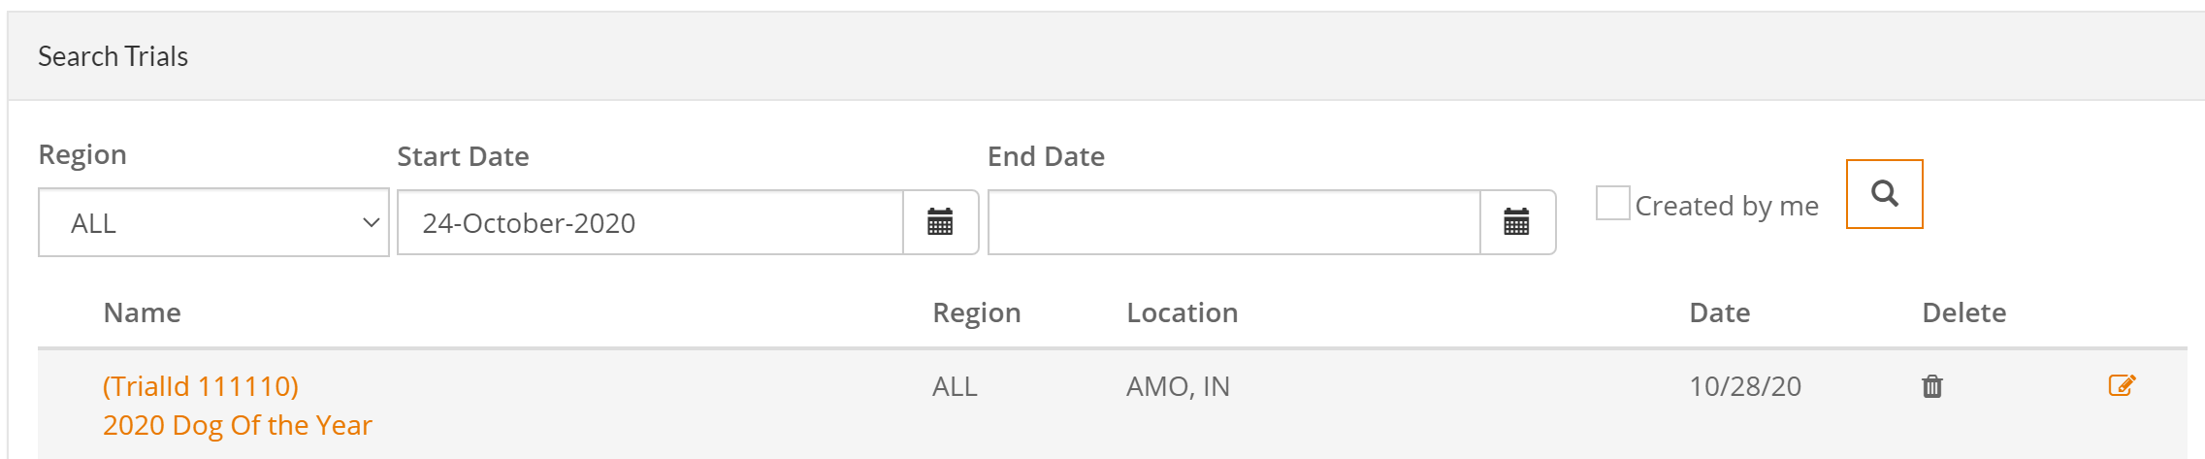
Once in the trial manager for a trial, you can go to fields & see what the trial rounds are & how many dogs move forward to the next round.
As an example for the 2020 Dog of the Year it is:
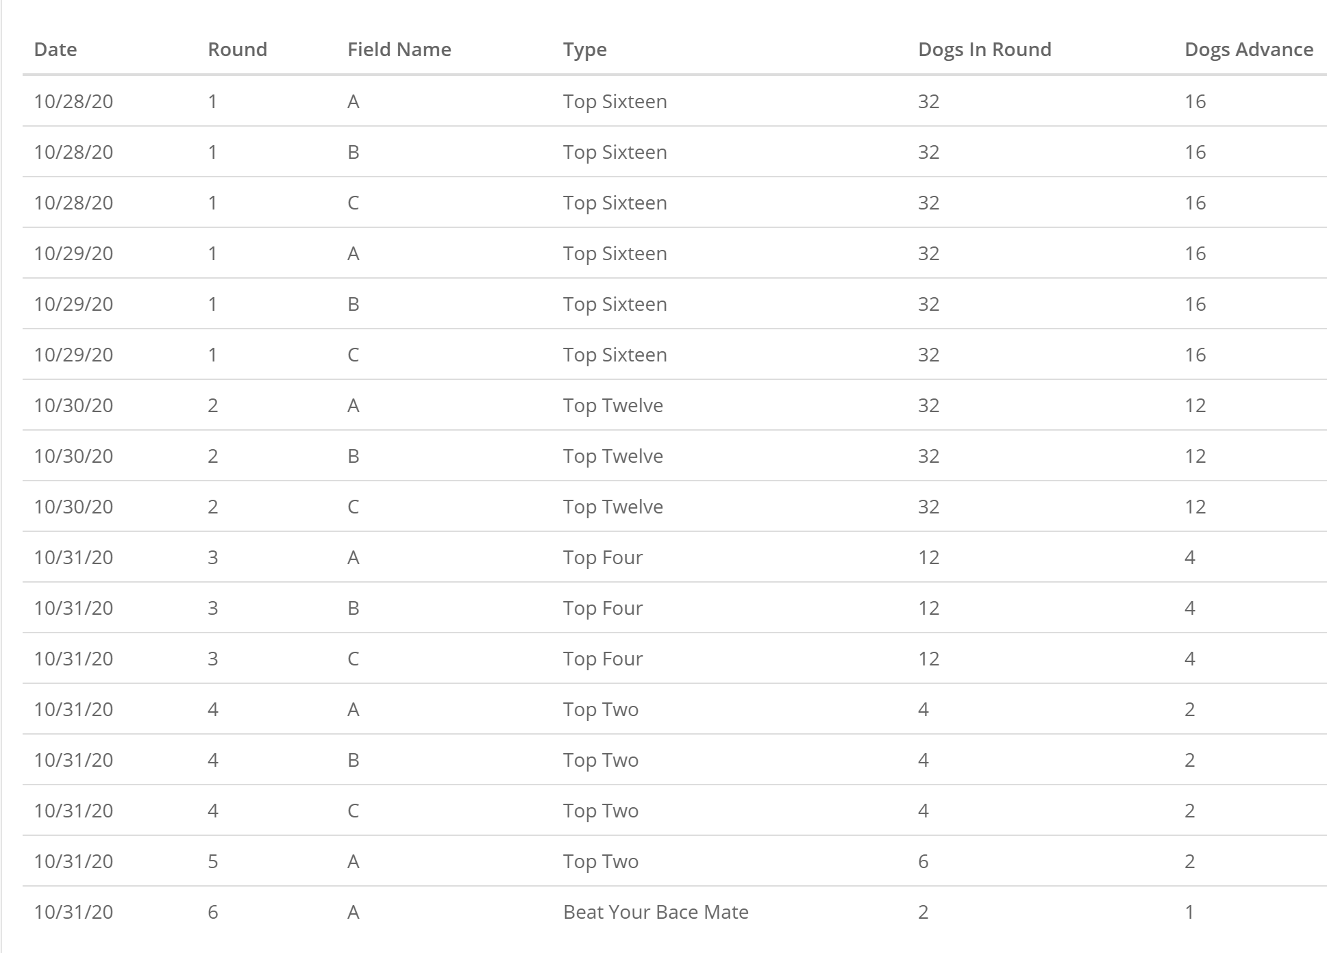
It is important to write this on the scoresheets & still people will ask you over & over. Beat your brace mate is the easiest because you don’t have to think – all the other trials have some combination of advancement.
After the 1st round has been drawn in all national trials, the rules need to be changed to disabled for same region dog – depending on your security you may not be able to see the rules & you will need to have the office disable it. The office is supposed to disable it after the first round has been drawn.
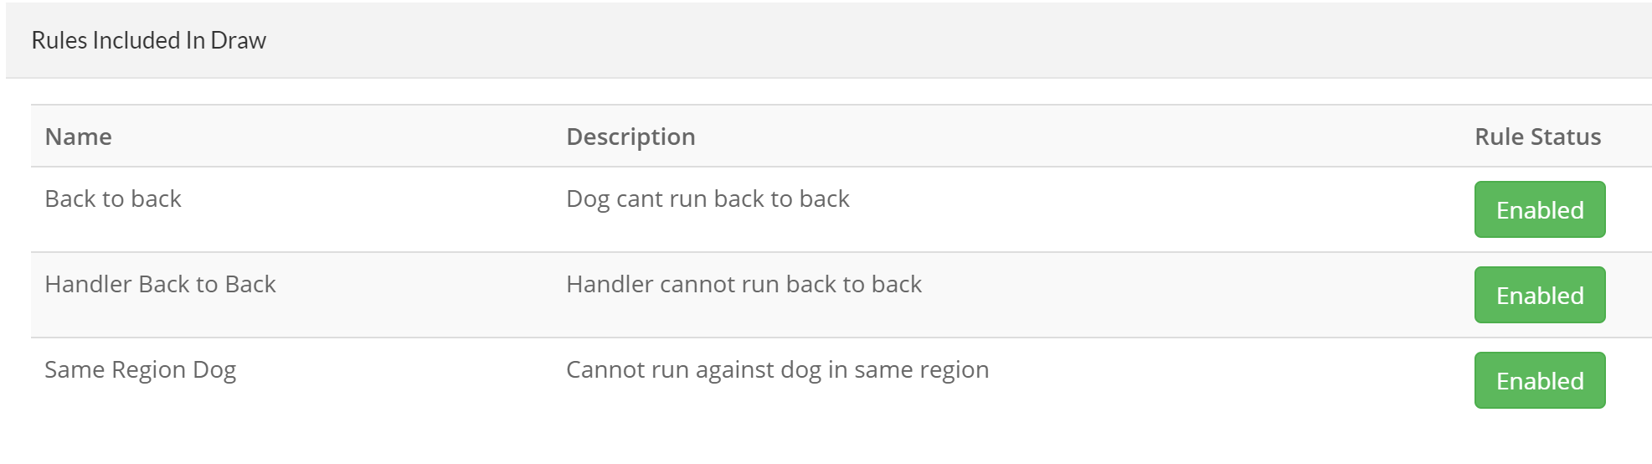
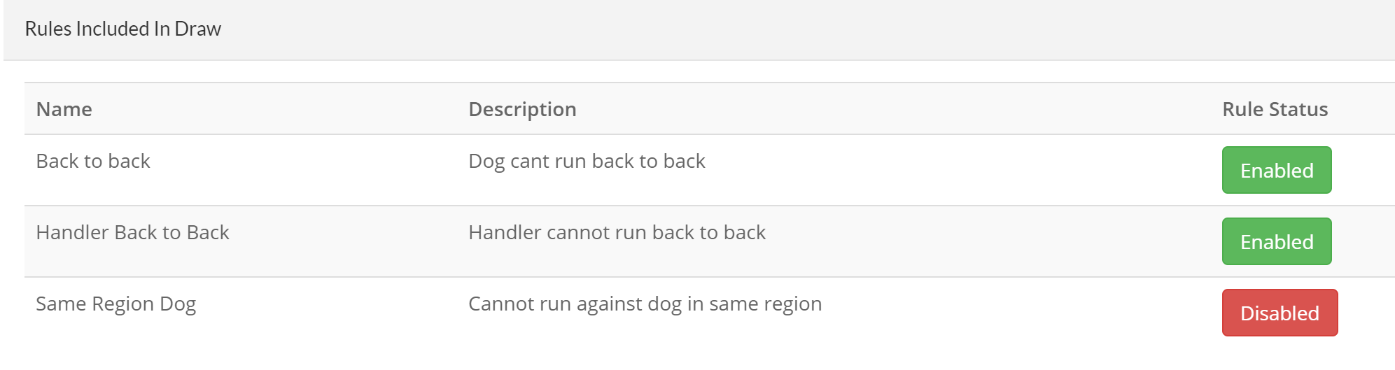
To enter scores, you will need to click on the + sign to add the finds & then the retrieves
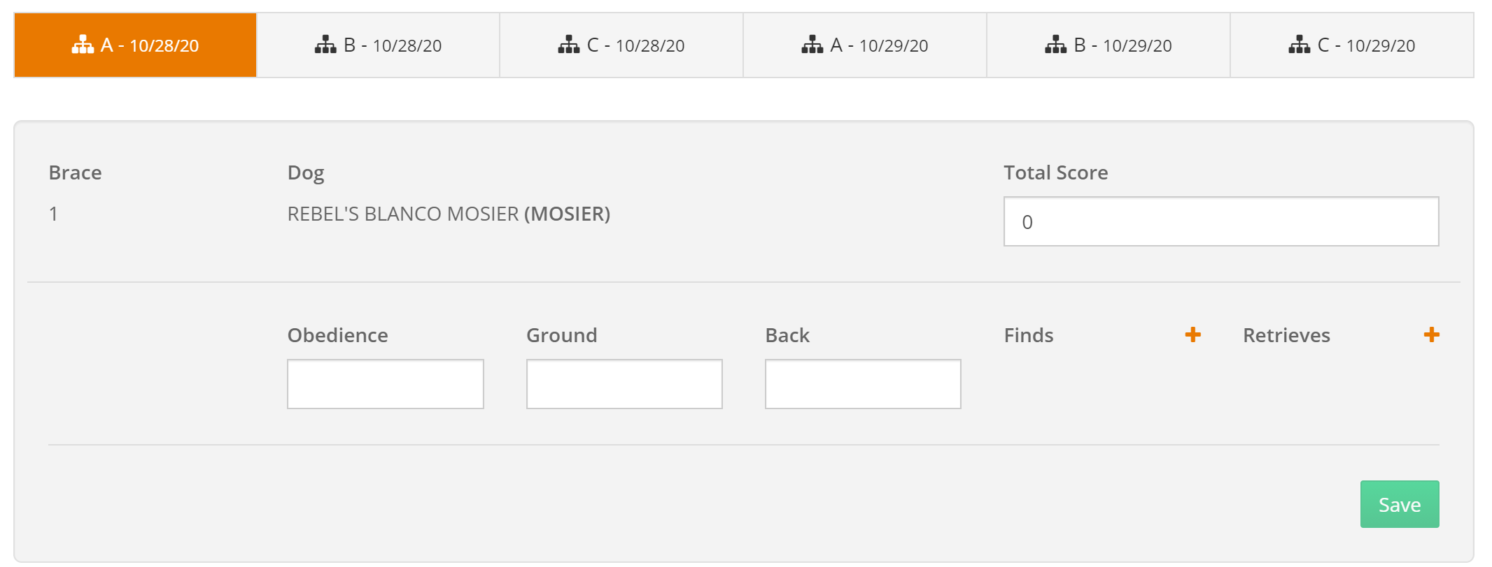
After you have entered everything – hit the save button. Usually, there is a retrieve score for ever find. Usually, safties are entered with an s/ or an a/ to indicate that this score is the average of all of the other retrieves. Other scores for retrieve might be a 0 if the dog refused to bring it to the handler or a / if the dog had no opportunity to retrieve the bird.
The system sometimes times-out & you have lost the connection – only way to know you have been logged off is when you click on the save button the green panel at the top of the screen does not appear. You will have to logoff & logon again because it appears you are logged on, but you are not.
I use my phone during the day to ensure that the scores are showing up correctly. It is very important that the total score is there and correct since that is what is used to advance the dogs.

To print out the labels – go to:
https://nstra-manager-prod.azurewebsites.net/login
you will get a logon screen – use your ID & password you use to logon to trial manager:
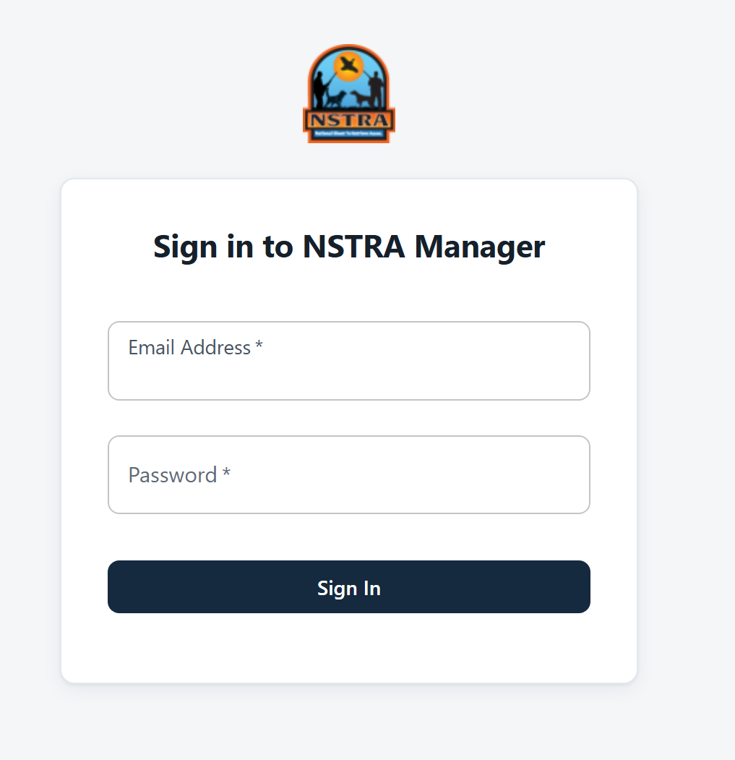
After logging in you will see this:
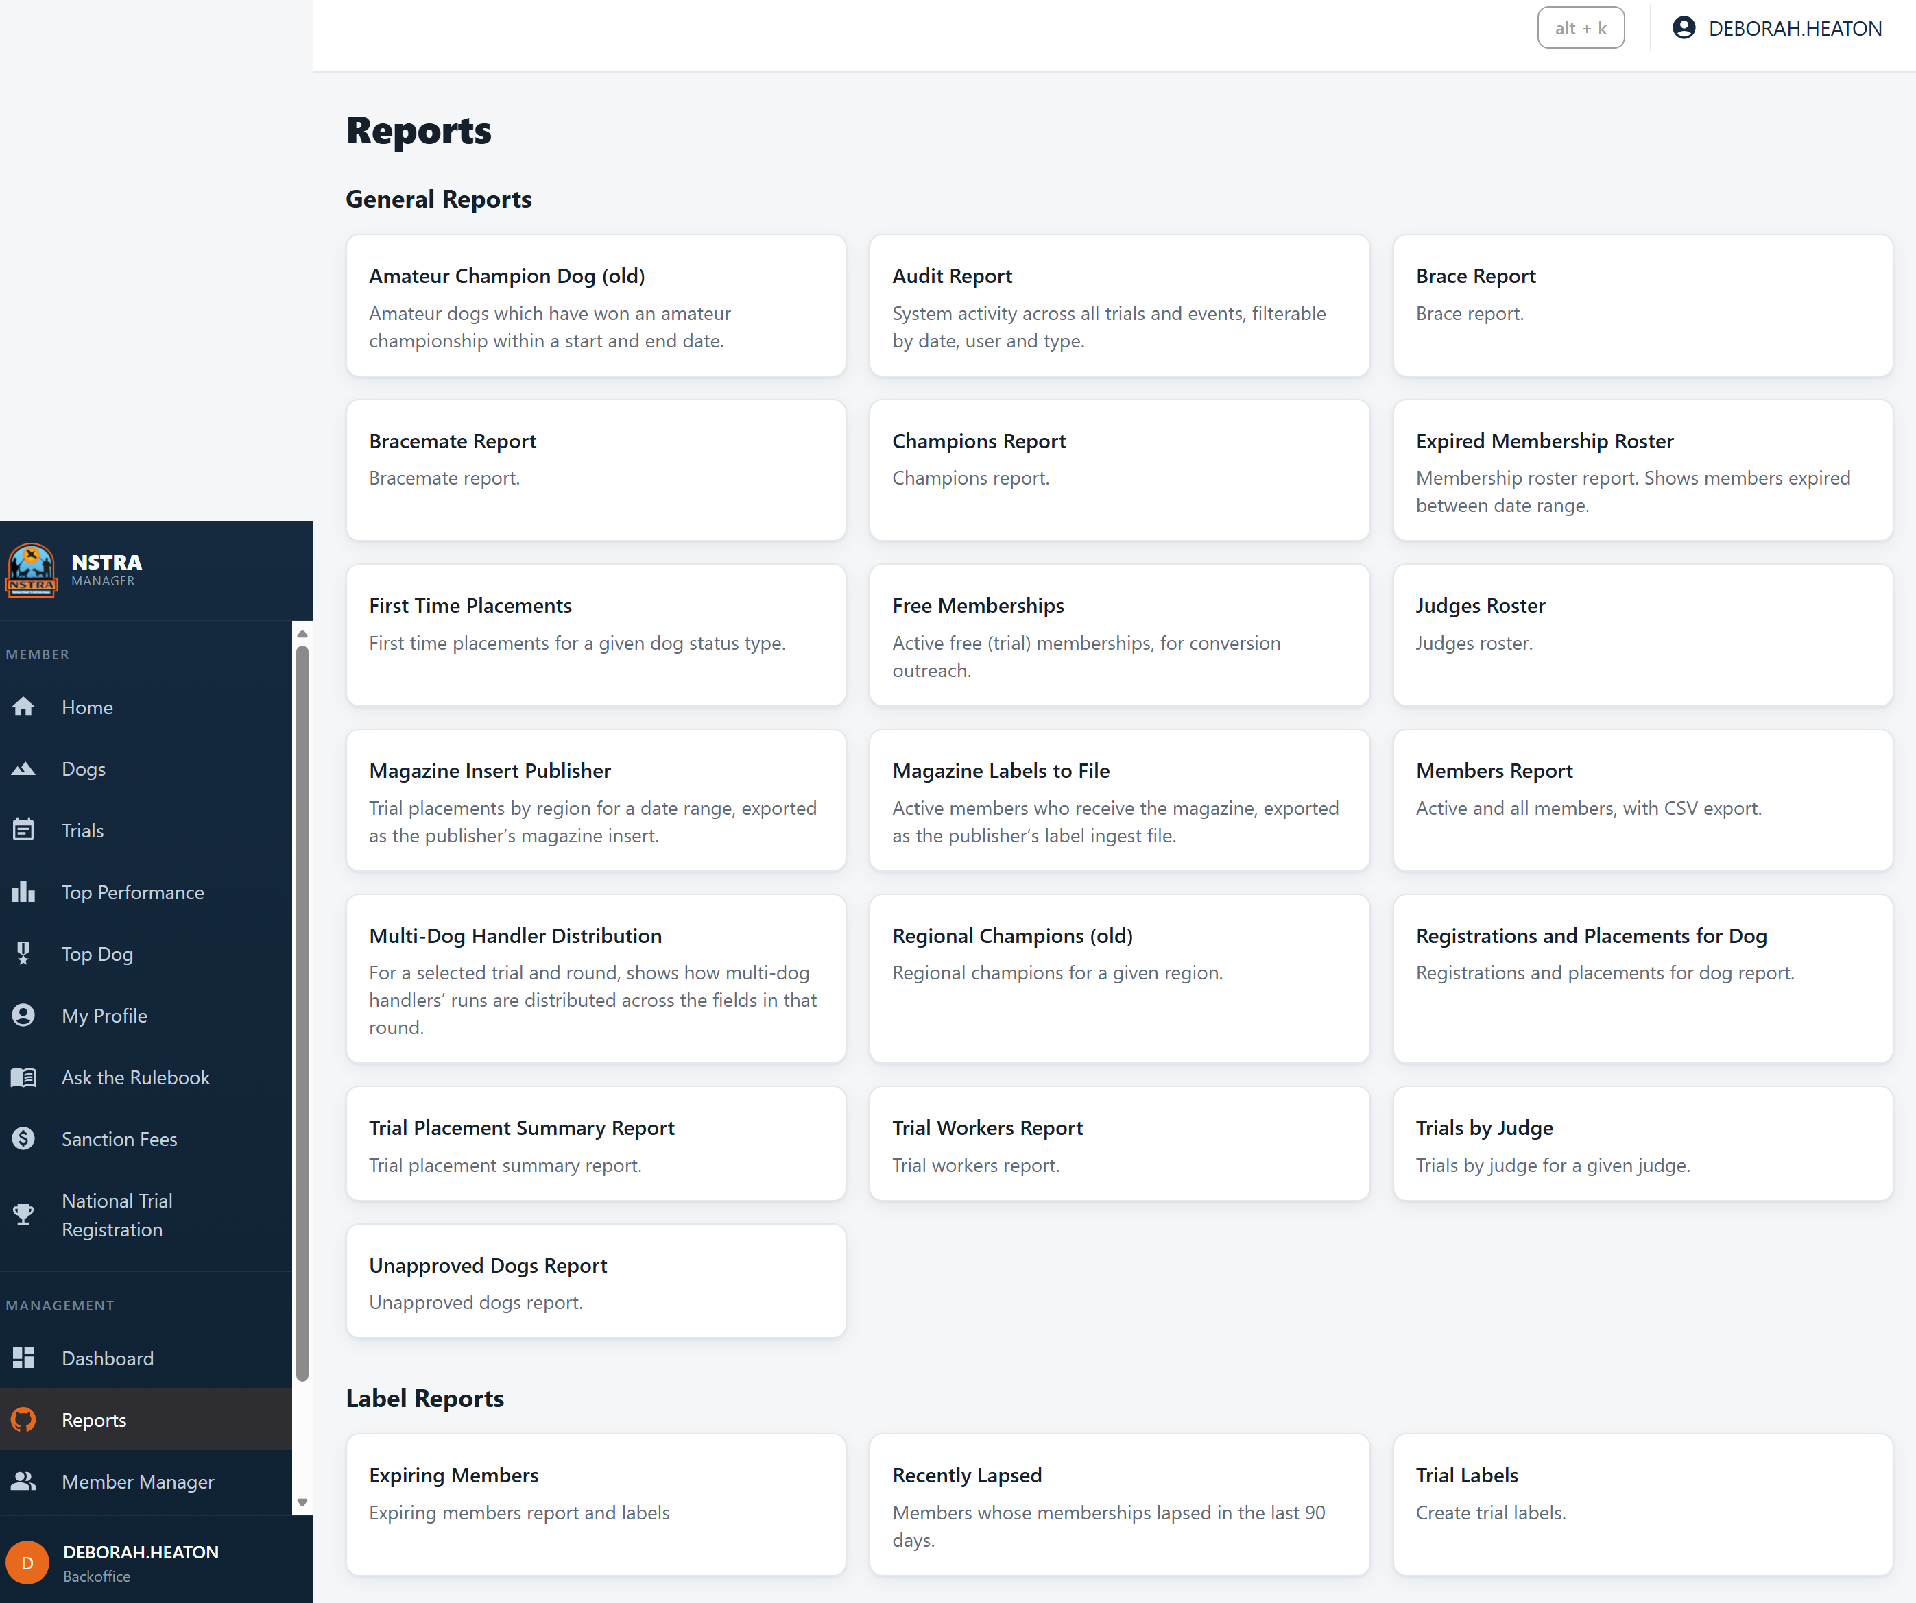
Click on Trial Labels – it takes you here – enter the date & click on search trials:
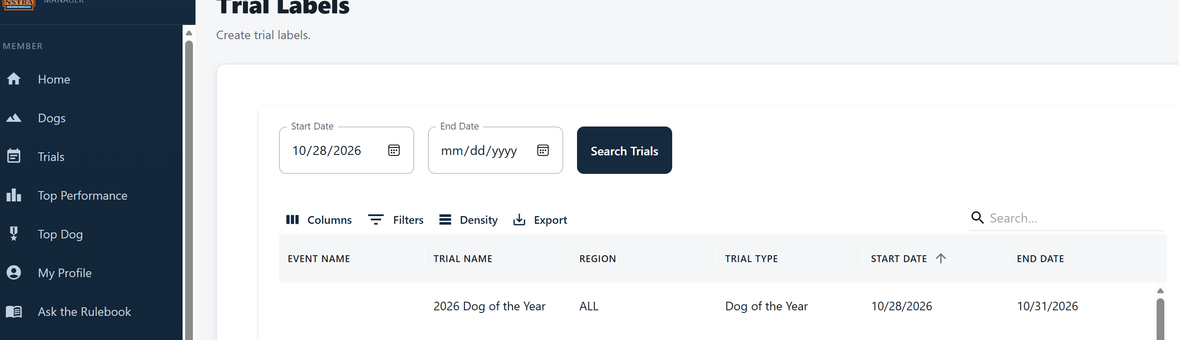
Click on 2026 Dog of the Year (or whatever your trial name is)
And it will show this at the bottom of the page:

I usually only use these for the first 2 or 3 rounds. It wastes too much paper for all of them.
The score sheet labels are printed on Avery form 5366 which is 1/3 cut (2/3 inches by 3 7/17 inches). Peel & stick on the score sheets.
The score sheet labels look like this: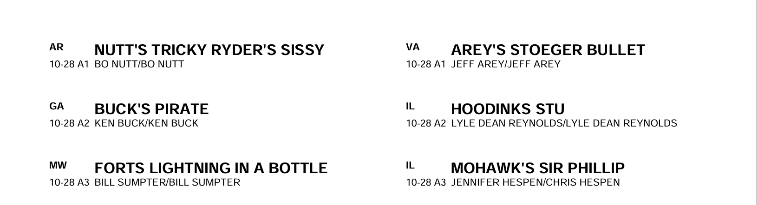
If you notice they start out with 10/28 for A1, then A2 – you will peel & stick the labels to the scoresheets – In Amo, you have to print them twice & make 2 scoresheets – one is official & it in the office & the other ones are hung up in the B & C field.
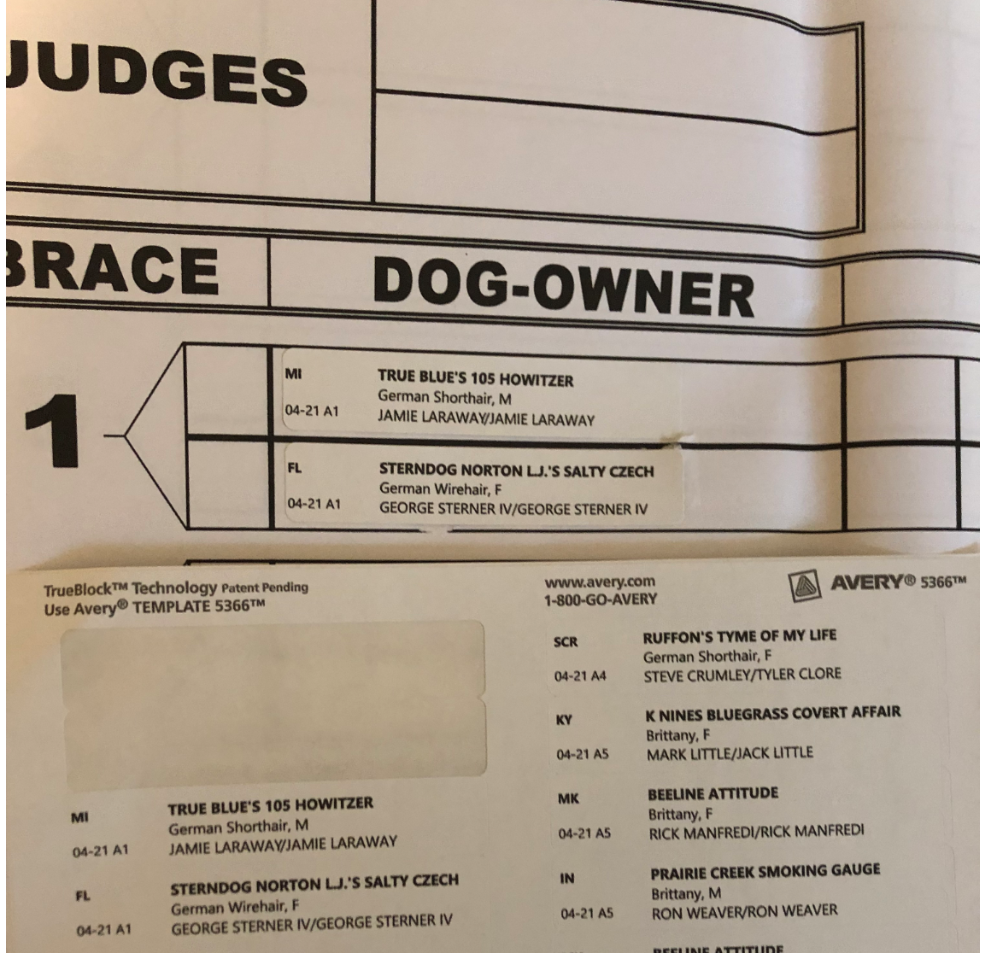
Go down the page until you have completed A field & the start a new score sheet for field B, etc.
Round Labels are for the score cards – it will have to be printed twice and is printed on Avery label laser/inkjet paper form 6791 that is 1 & ¼ inches x 1 & ¾ inches rectangle labels. They look like this:
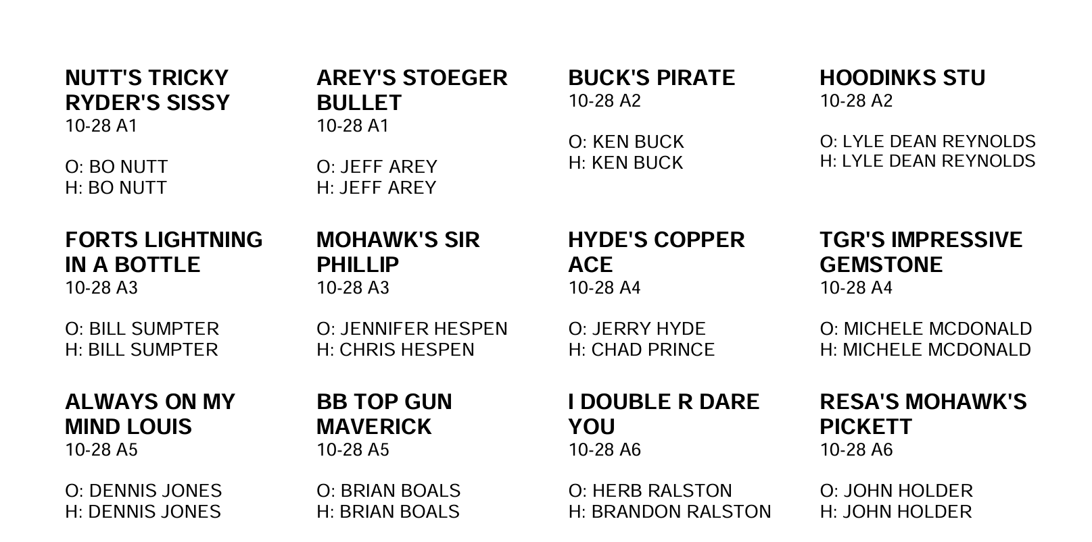

You will take A1 for each page & stick it on a score card – best to align 2 cards as seen here:

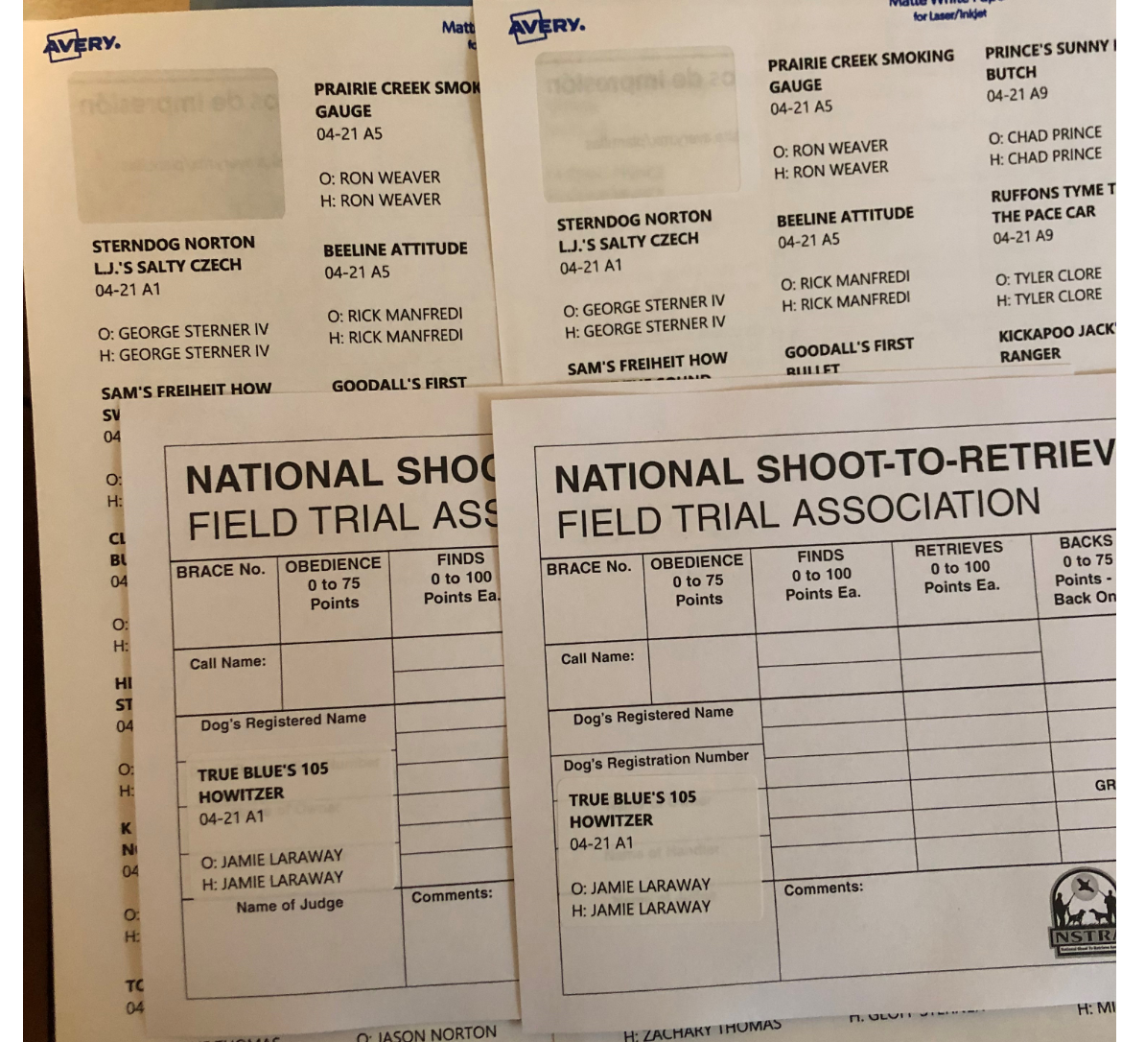
Flip the cards over and then stick the A1 dogs to the other side:
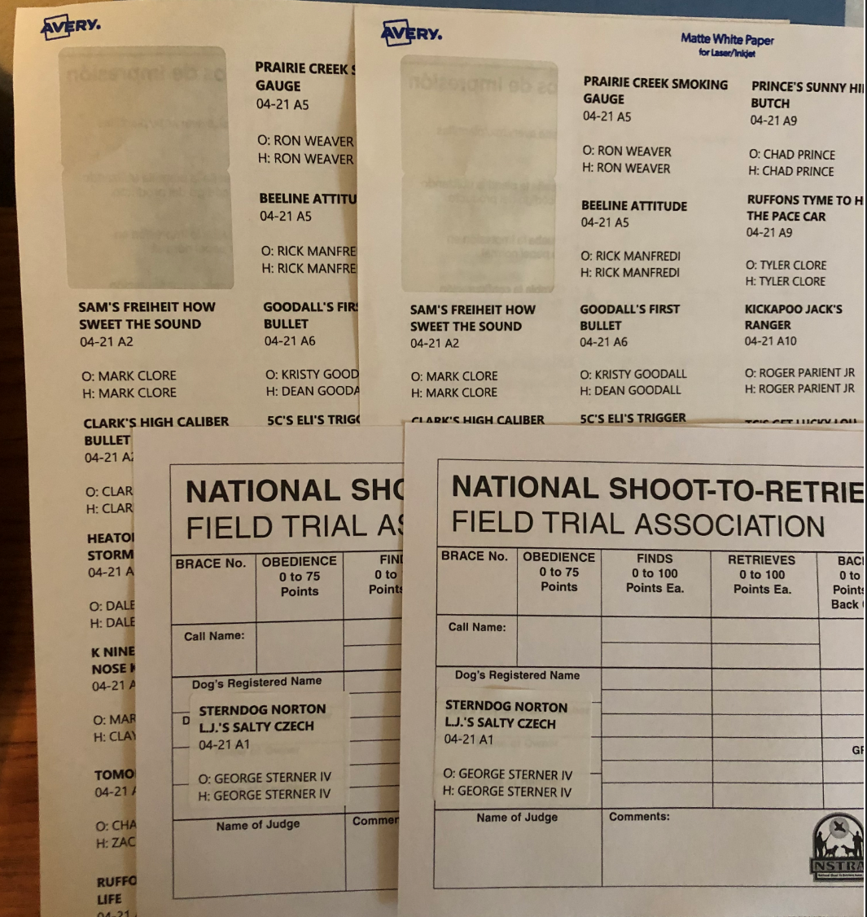
Remember, there are two judges in each field & each judge will need 1 score card with each dog name in the brace.
At DOY & TOC, the bird planter will be asked to bring the score cards to you – you will need to check the score & communicate with the marshals for any discrepancies.
When I am scoring the cards, I try to write on each card so that I can sort them by the score – it makes it easier to keep up with the top 16. It also makes it easy to spot ties. You can also go to live scoring & sort by score to get the top 16 or whatever the advancement number is..

Each night, you will need to enter the placements by field – go to the points tab and click the add placement dog for the first four dogs. Make sure that this agrees with the score sheet – if one of the dogs in the first 4 is a paid bye see next instructions:
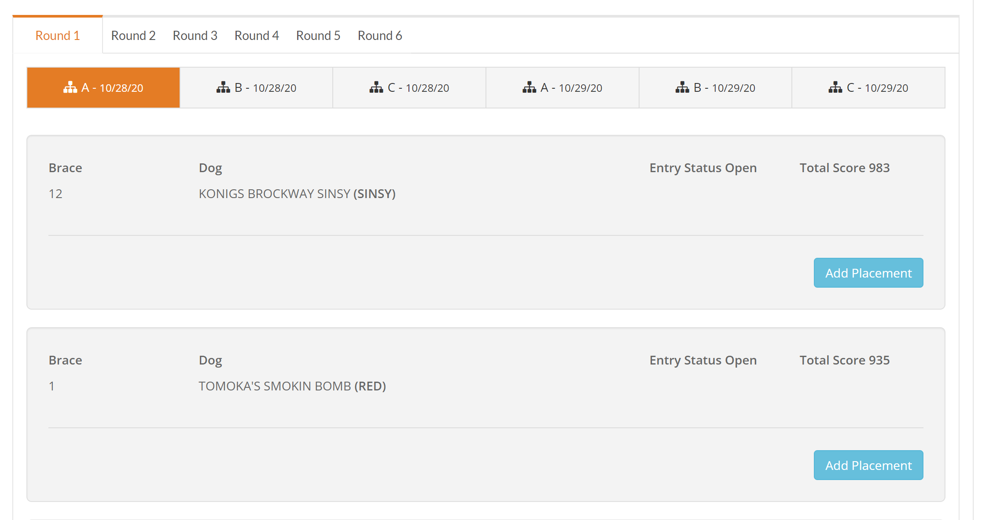
After selecting the top 4 dogs in the elimination rounds, go to the bottom of the page & enter the placements.
1st place example:
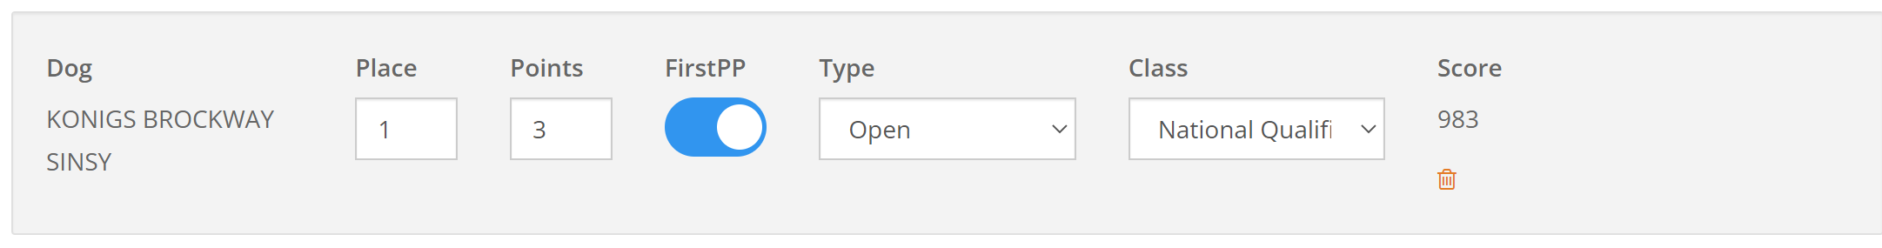
2nd place:
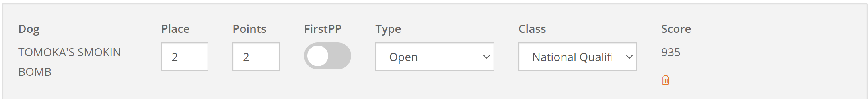
3rd place
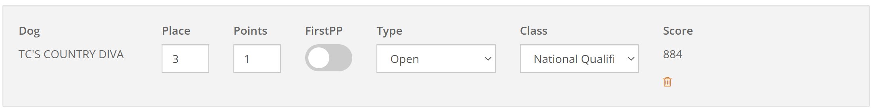
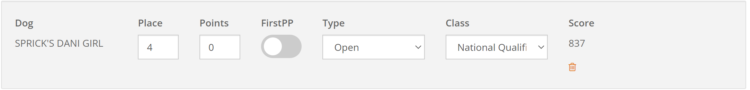
If you have a bye dog (a dog that cannot advance, but paid $50 for a placement) – DO NOT enter a score for that dog & it is listed in the draw as a bye dog. If it places, go to the Points tab:
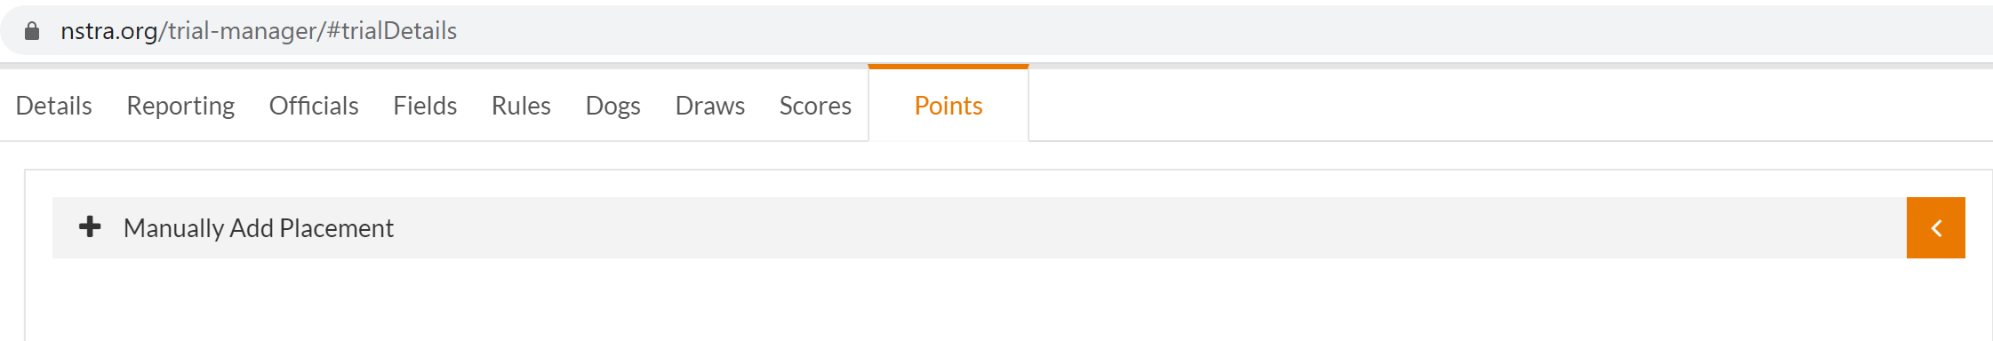
Expand Manually/Add Placement:
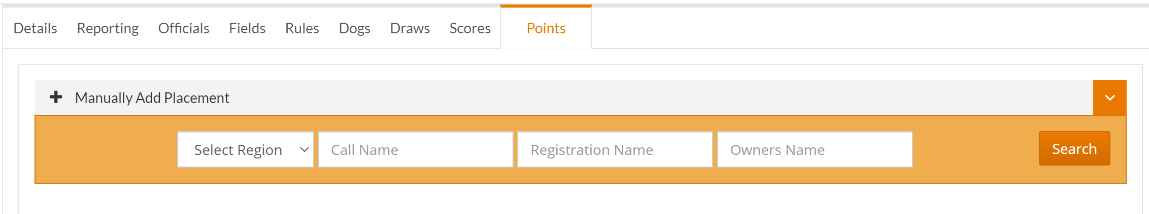
Enter the dog’s region, call name & owner – then hit search –
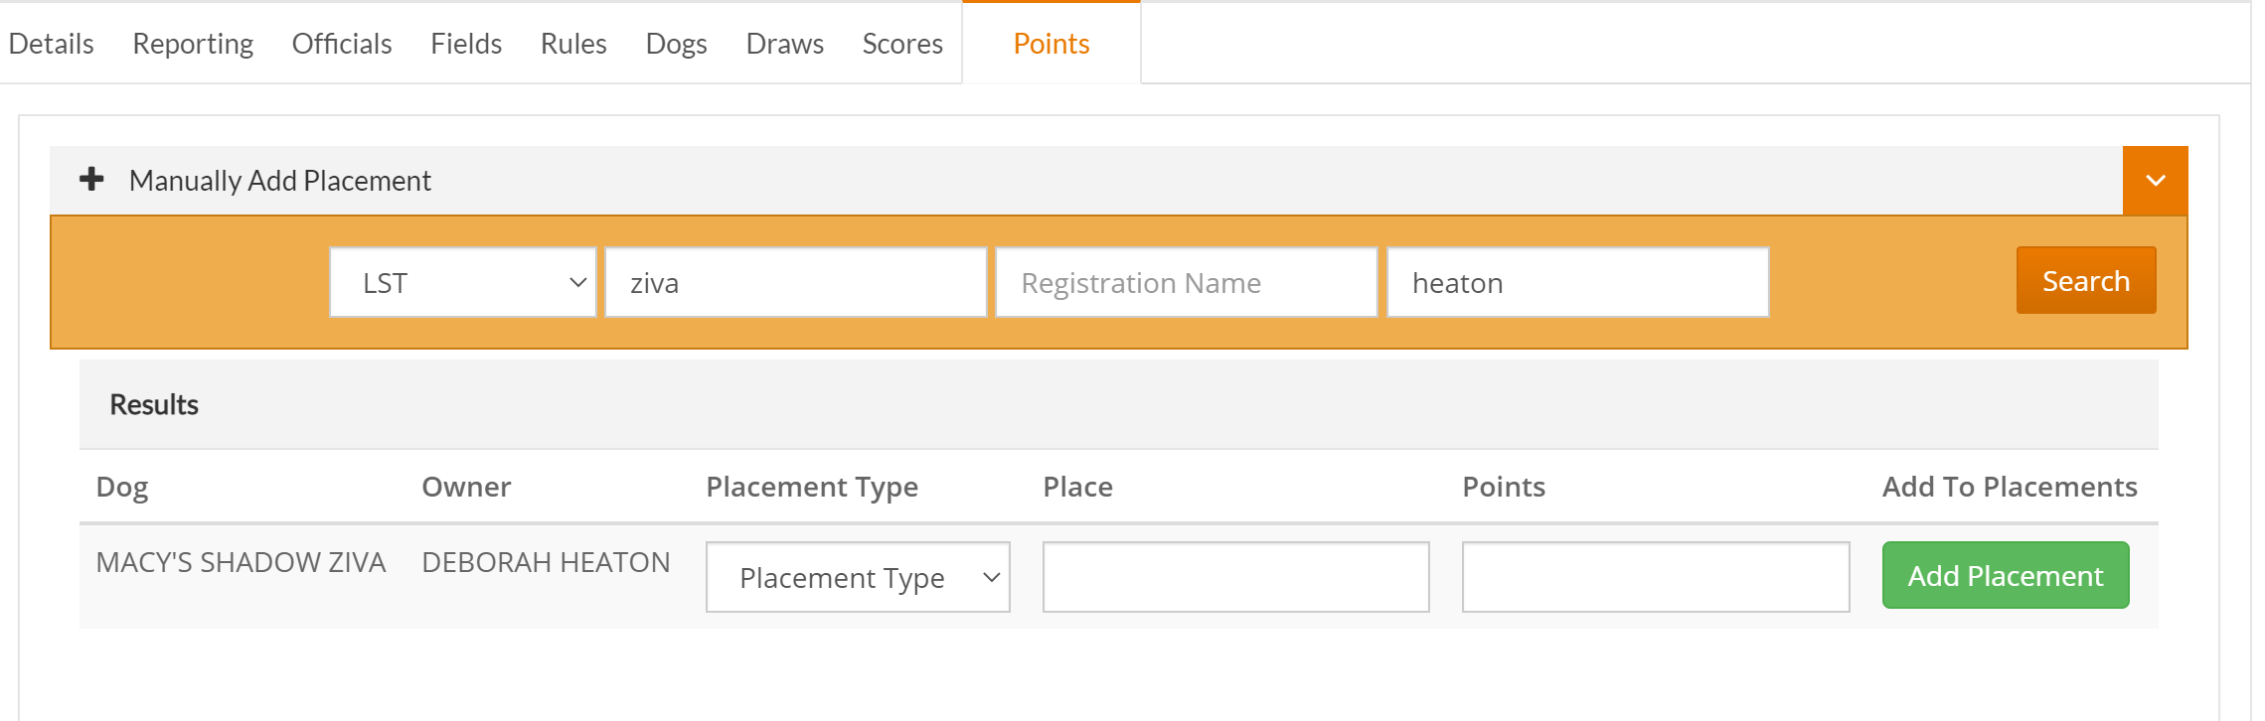
Enter the placement type, place & points (this is their score) – then hit add placement
You will need to go to the bottom & a number of point for their placement – 1st is 3, 2nd
is 2, 3rd is 1 and 4th is 0.

The reason that it is important to add the placements as you go, the placements at the bottom are sorted by score & at the end of the day, you have a long list of placements with no designation of what field the come from – as an example:
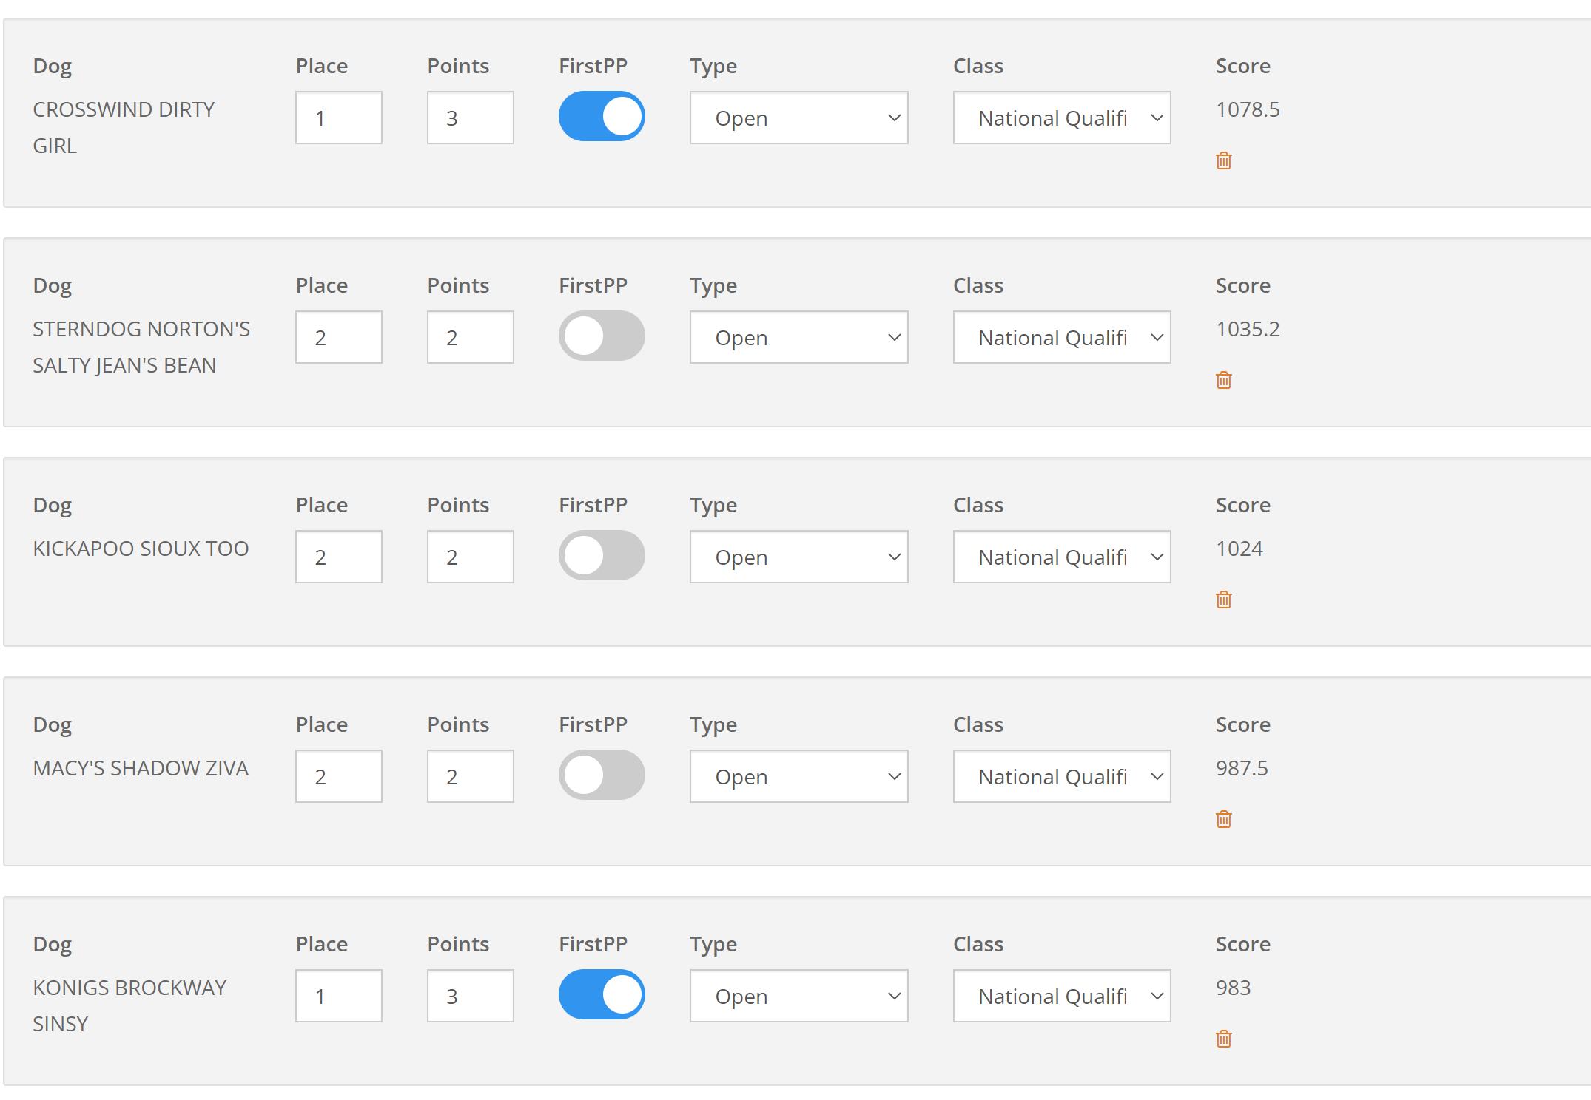

On Saturday after the trial have finished, go to the last round & enter the placement for the final hour dogs – remember that the top six places are always first place points - Click add placements & then go to the bottom of the page & enter the placement – 1st place gets 6 points, 2nd place gets 5 points, 3rd place get 4 points, 4th place get 3 points, 5th place gets 2 points & 6th place gets 1 point. (that was changed in 2025 starting with the UKC trial)

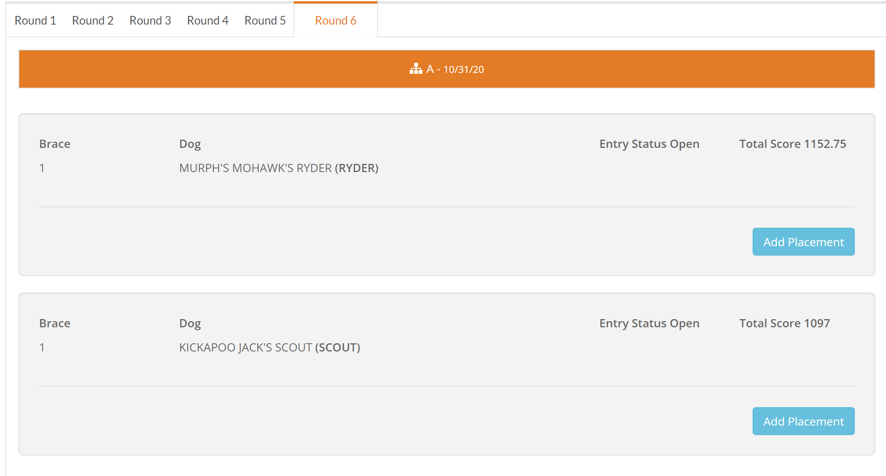

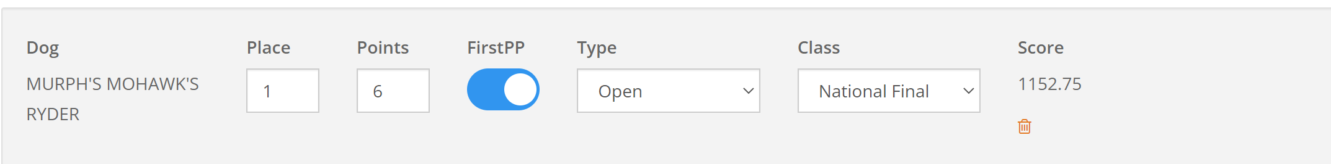
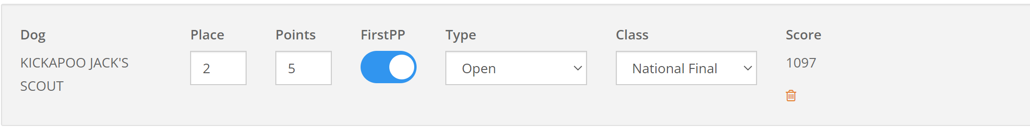
Now go to the previous round & add placements of the dogs that came in 3rd & 4th.
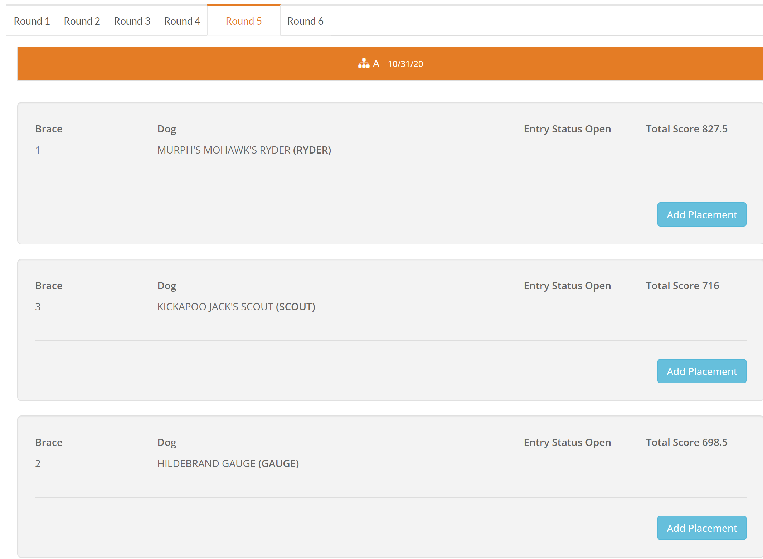
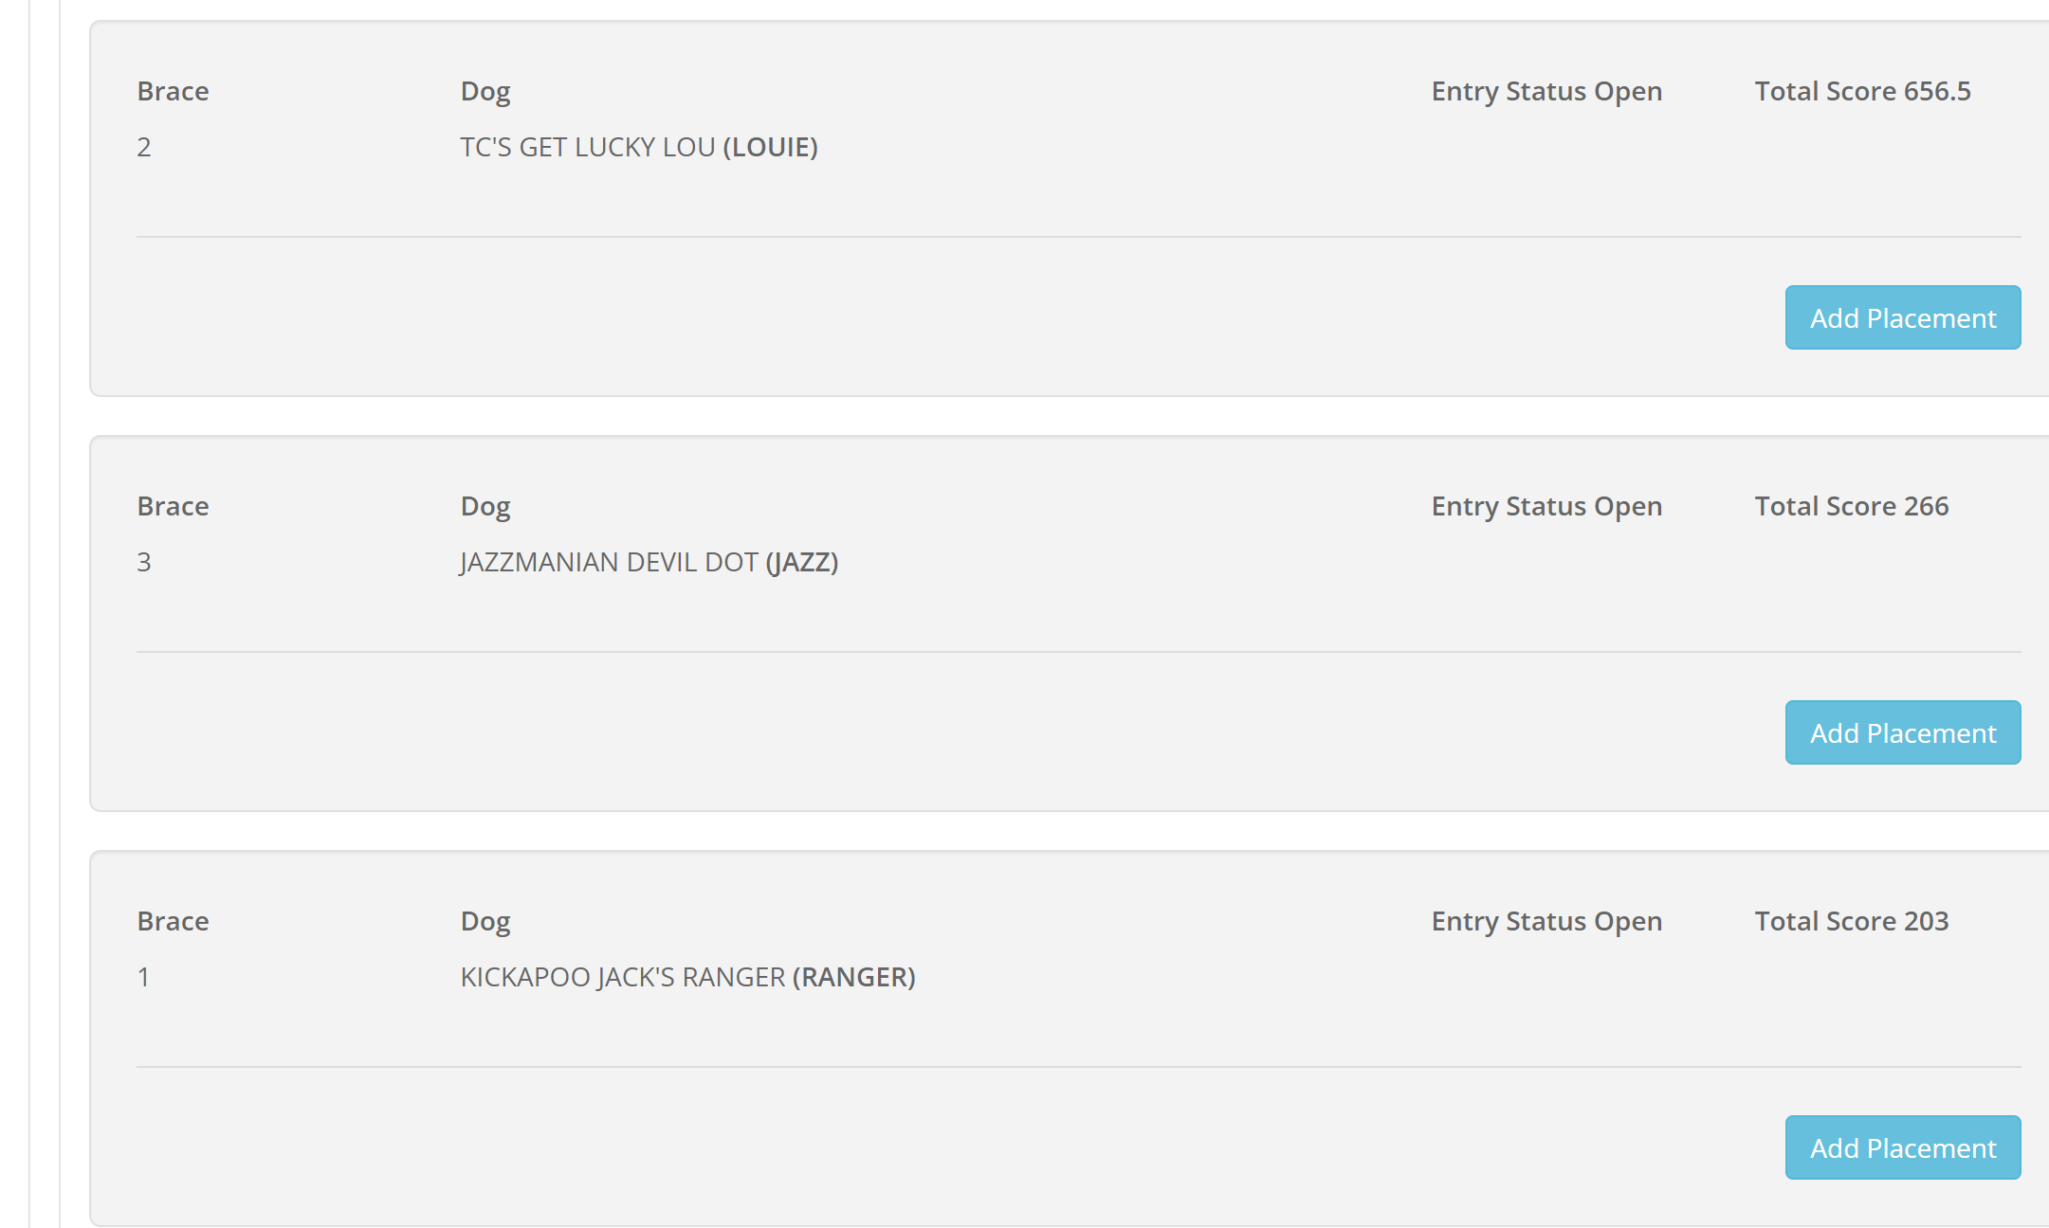
So added 3rd place for Gauge & 4th place for Louie – go to the appropriate round until you have identified the top 6 with points – the placements are not complete until you have identified the top 32 dogs – with place 7 thru 32 getting 0 points. This is tricky when it is beat your bracemate because a dog with a high score could have been eliminated by a higher score. I use my excel worksheet that I created to keep up with scores & use it to eliminate the dogs that did not win their brace.

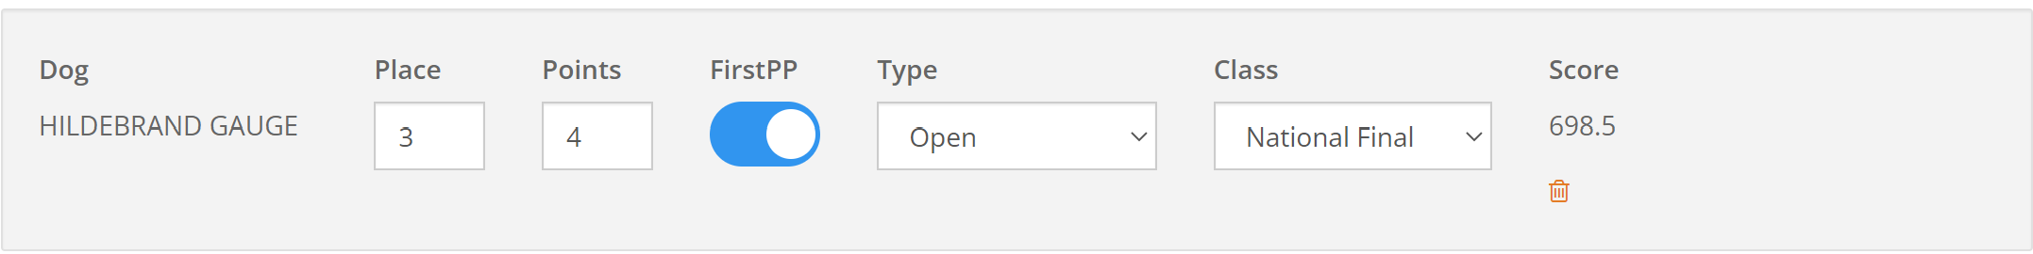
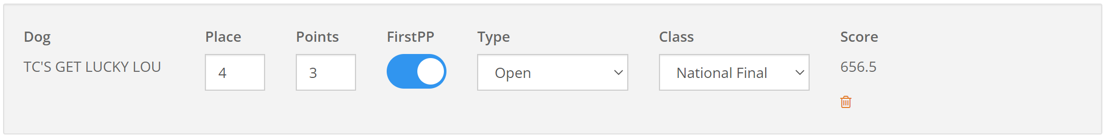
Load the article & pictures to
Dropbox.com with logon: office@nstra.org & password Nstra26! – it is a free account.
The first time you login to the dropbox, be sure the office is there – it is doing 2 step authentication now & it will send a code to the NSTRA email & you will need that to continue
You need to take a lot of pictures – hopefully, someone will take pictures & share with you. Need placement pictures, action pictures, auction pictures, dinner pictures, final 4 or 6, or 8, official pictures. I try to ensure that alcohol is not shown in the pictures for the magazine.
In the magazine, you will also need to show the scores – I use Microsoft edge to download it to excel & then enter the scores in excel. Looks like this when I bring it in:
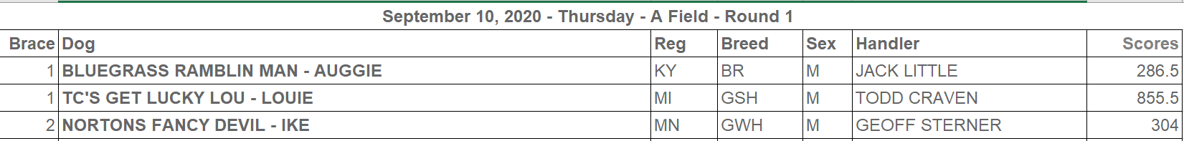
Bring up the trial record in a browser (you are not logged on to trial manager because it looks different in trial manager) – copy the brace info listed about & the open an excel worksheet, say paste special then select text & it will come in to excel like the list above.
since each trial has a different number of rounds, I also start with & old one & then adapt. This is probably the hard way, but it does allow me to analyze the number of regions represented & the types of dogs. Also, I start with the file that has the call names & then for the article parse out the call name. You could also just use the excel file that is created in the draw tab & add a scores column. It is up to you.
Brace | Dog | Handler | Scores
1 | REBEL'S BLANCO MOSIER (MOSIER) | JOHN TROUT, JR.
1 | TOMOKA'S SMOKIN BOMB (RED) | MIKEAL MULBERRY
2 | POWER'S EASY MONEY (MONEY) | JOHN RESA
2 | RUDD'S RUNNING RUSTY (RUSTY) | SUVOYEE RUDD
3 | RUCK'S BROCKWAY TWIST (TWIST) | TOM ROTUNDO
3 | BARR'S SMOKIN MOONSHINE R'MILEY (MILEY) | RONNIE BURNETT
4 | SMART LITTLE SKEETER (SKEETER) | RON SIMMONS
4 | K'S DIALING DAMASCUS (BRIAR) | ED FORD JR
5 | CROSSWIND LITTLE MAN PAPPY (PAPPY) | JOHN CULLEN
5 | CRIPPLE CREEKS MIGHTY CASEY (CASE) | JODY BASS

I you want to bypass keeping up with the scores as you go, after the fact, you can go into the trial manager after the trial & download the draws again, the scores are populated based on what was entered into the system.
Brace | Dog | Handler | Score
1 | SHADOW'S TY (TY) | SCOTT SCHWIMLEY | 530
1 | FORTS LIGHTNING IN A BOTTLE (GENIE) | BILL SUMPTER | 285.5
2 | ZIVA'S LINKED T REX (REX) | DALE HEATON | 630
2 | BLUEGRASS FAT BOTTOM GIRL (QUEEN) | CLAY LITTLE | 528
3 | BLUEGRASS APACHE OUTLAW (CHIEF) | JACK LITTLE | 619.5
3 | BUCK NAKED JIM (COCO) | JOHN WIESMAN | 667
4 | KICKAPOO'S SAMUEL ADAMS (ADAMS) | ETIENNE LAVOIE | 725
4 | YAK TUFF ENUFF RIP (RIP) | BRUCE SWANSON | 298
5 | HEATON'S CASSIDY (CASS) | DALE HEATON | 710
5 | TROOPER'S TWERKIN KNOX (KNOX) | JOEL CARTWRIGHT | 526.5

– this is what I got from Olivia about the article format:
please use Arial the font size to 10 pt. As to the margins, the use 1.2” for top, bottom, left & right. Don't forget to leave me some additional room on the first page to put a big heading.

